植物抗病性小组
研究小组成员：方斌 孙继超 温兴 胡艳
指导老师：周俭民博士、张跃林博士
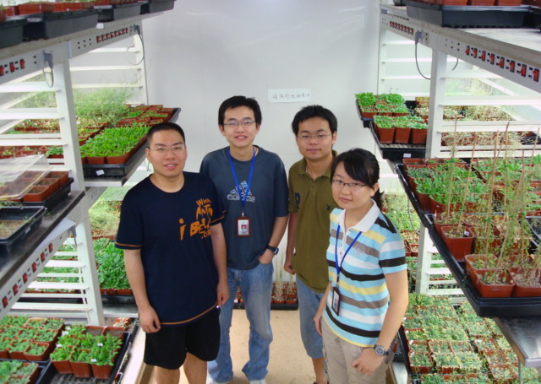

Report
Who on earth is the mobile signal of SAR? MeSA?
Background
SAR refers to a distinct, integrated set of signal transduction pathways, which is triggered by a local pathogen challenge. SAR can be distinguished from other disease-resistance responses by the spectrum of pathogen protection. The induction of what is referred to as the SAR-marker genes is tightly correlated with the onset of the SAR in an uninfected tissue. Over the past decade, considerable effort has led to the identification of the mobile signals involved in the establishment of SAR . However, results obtained from the detachment experiments on P. syringae infected cucumber leaves and the grafting experiments on tobacco plants indicate that SA does not appear to function as the systemically transported signal. Several lines of evidence support the hypothesis that a lipid-derived small molecule may be a mobile signal for SAR. Additional evidence for a role of lipid signaling in the SAR comes from studies on tobacco plants. And then studies from Klessig (Science,2007)also indicated that one of two translocated signals that induce SAR is MeSA. But the results was doubted while we want to determine whether MeSA is one of the mobile signals of SAR in tobacco.
Ideas
What is the signal ? like a letter from far far away ? a electron through wire? a inform from foreword to backward in formation?
Every part of detail can tested and gathered to a process while we think there is no need to just fix to every detail to know the whole and we consider the whole as a “black box” , assuming the inside according to the input and the output.
There maybe have two kinds of signals: 1, which triggers SAR ,transported to upper crown to get their functions with or without decrease during the transportation in tissues ;2.which are kept by every living cell it meets to a certain rage. And the latter is our interest and assumption.To ensure that, we can design experiments: Get plant cells from the stem of tobacco after inoculation to test SAR.(Can phloem itself be triggered?/How does the distance influence SAR? Graft experiments).
So plant cells which are capable to “transport” SAR need that reception of the molecules is the cause of synthesis of it at first and all the other hormone and the sequent SAR would be not influenced and elicited before its reception. Then we revalued the discovering from pioneers and precursors to ensure our further assumption that MeSA is one of the mobile signals of SAR. experiments.

1.1 Make sure the receptor of MeSA is SABP2 in single cell and in tissue.
1.2 Mutate and overexpress the receptor of MeSA
1.3 Test the synthesis of JA or SA and the sensitivity of SAR

2.1. Tag the process by product or proteins downstream in single cell and in tissue.
2.2. Tag synthesis of JA and SA
2.3. Compare according to the timing.

3.1 Would the initial MeSA make single cell to enhance the synthesis of MeSA at first in single cell and in tissue? (There is a peak?)

4.1 Further analyze the receptor of MeSA and its interaction with other proteins downstream or where its production is going and find the net going.
Results expected
1. There has a relative relation between the synthesis of JA or SA and the sensitivity of SAR and the receptor of MeSA, and the latter maybe cause or influence the former.
2. The reception of MeSA causes or influences directly or indirectly, which really is upstream the synthesis of JA or SA and the sensitivity of SAR.
3. Further confirm the conclusions.

Blueprint
MeSA
MeSA
?
?
?
MeSA
?
JA synthesis
MeSA synthesis
MeSA
SA synthesis
Plant cell
?

